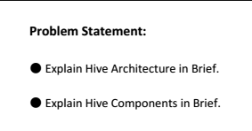

**Explanation:-**

**HIVE COMPONENTS:-**

There are 4 hive components. They are

* Driver
* Compiler
* MetaStore
* Execution Engine

1. **DRIVER:-**

* Driver is the hive component which intercepts and parses your query and **checks it for syntactical validation.**
* If the query written is wrong, then Driver will throw error message.
* If the query is Syntactically right, then the data will be parsed by next component named Compiler

1. **COMPILER:-**

* Compiler is the hive component which creates an execution plan and returns back to the Driver.
* The Compiler creates the execution plan with another component called **MetaStore.**

1. **META STORE:-**

* Meta Store is an active component and an application which stores and manages the metadata that you generate on hive Shell.
* Metastore Applications has all the logic to manage the metadata provided by Hive Framework.
* Metastore comprises of two parts. They are

Meta Store Application

Meta Store DB (RDMS)

* Whatever DDL (Data Definition Language) activities we are doing, It generates metadata and it will be stored in MetaStore.

1. **EXECUTION ENGINE:-**

The Execution Engine is the hive component which executes the execution plan created by compiler.